STAT 218 – Week 4 Lecture 2

HYPOTHESIS TESTING

Statistical inference draws a conclusion about a population parameter based on a sample statistic. The two major procedure types are confidence intervals and hypothesis tests.
- A confidence interval estimates the value of a parameter with an interval of values.
  - We’ve already learned that yesterday..
- A hypothesis test assesses the plausibility of a particular claim about the parameter.

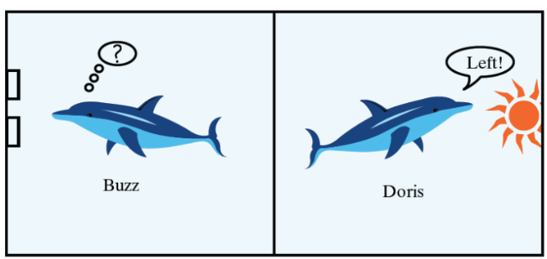
And if you remember, we had two dolphins on Friday and we assessed the plausibility of a particular claim which was “Dolphins can communicate abstract ideas in the long run” without delving into technical details of hypothesis testing. Let’s remember what we’ve done.

We…
- identified research question: Can dolphins communicate?
- identified variable: A binary variable – whether Buzz pushed the correct button or not
- calculated statistic: # of correct buttons (15 out of 16) OR proportion of pushing the correct button ($\hat{p}=0.94)$
- listed possible explanations for why “Buzz pushed the correct button 15 out of 16 times”.
Let’s list these possible explanations one more time in a tidier way:
- If he and Doris could communicate,
  - Buzz pushes the correct button more often than he would
- If Buzz and Doris could not communicate, either
  - Buzz would just be guessing which button to push (very lucky on that day)
  - There must be something related to experimental design
    - Are we sure Buzz couldn’t see the headlight around the curtain?
    - Are we sure there was no pattern to which headlight setting was displayed that he might have detected?

Let’s assume that nothing is wrong with the experimental design. There are 2 possible explanations left:
- Buzz was just guessing
- They can communicate in the long run

!Our job was to decide which explanation is more plausible to believe!
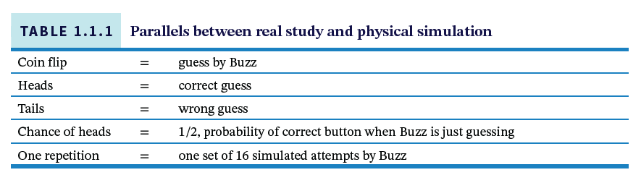
- To be able to decide which explanation is more plausible to believe –and convince our non-statistician friend 😊–, we modeled the first explanation (Buzz was just guessing which button to push) by using a coin (computer, actually) and simulating Buzz’s behavior. Here is the summary table to show use similarities between real study and our simulation.
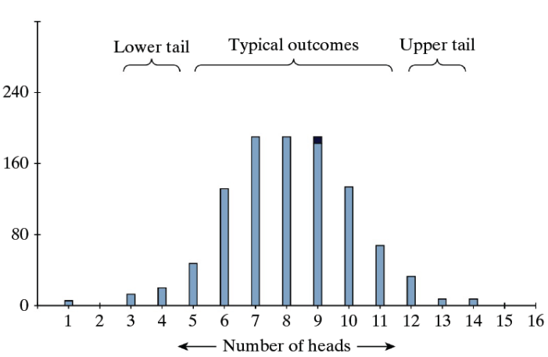
Below, you see 1,000 repetitions of flipping a coin 16 times.

When we repeated Buzz’s 16 attempts using a coin flip, we found that achieving 15 heads out of 16 attempts was extremely rare. In fact, across 1,000 simulated sets of 16 attempts, not a single instance of 15 heads occurred (0/1000 = 0).

IMPORTANT! To be clear, we’re not saying that 15 heads is impossible—just that it’s so rare that we couldn’t capture it in 1,000 trials.)

Our coin flip chance model provides strong evidence that Buzz was not simply tossing a coin to make his choices.

- This means we have strong evidence that Buzz wasn’t just guessing.
- Therefore, we don’t believe the “by-chance-alone” explanation is a good one for Buzz.

- In the end, we concluded that both explanations were still possible, but the second one seemed more plausible (they can communicate in the long run).
We actually conducted hypothesis testing last yesterday (see the summary above), but as I mentioned, we didn’t use any technical terms for it. Now, let’s formally define it!

Can Dolphins Communicate: From the Lens of Hypothesis Testing
Before re-delving into this question, let’s learn elements of a statistical hypothesis test:
- The null hypothesis, denoted by H0, is the claim being tested. The purpose of the test is to assess the evidence against the null hypothesis, which is typically a statement of “no effect” or “no difference” or “due to random chance”. The null hypothesis is a statement about a population parameter.
- The alternative hypothesis, denoted by Ha, is what the researchers suspect to be true, as opposed to the null hypothesis, about the population parameter.
- The standardized statistic (or test statistic), which summarizes the difference between the observed value of the sample statistic and the hypothesized value of the population parameter by dividing by the standard error.
- The p-value is the probability, if the null hypothesis were true, that the sample data would produce a test statistic value at least as extreme as the one actually observed.
  - The smaller the p-value, the stronger the evidence against the null hypothesis.

Now we are ready to map Dr. Bastian’s study by using these terms/elements.

Example 1: Can Dolphins Communicate?
A famous study from the 1960s explored whether two dolphins (Doris and Buzz) could communicate abstract ideas. To investigate this, Dr. Bastian spent many years training Doris and Buzz and exploring the limits of their communicative ability. In one of these trainings:
- When the headlight shines steadily, this was meant as a signal to mean “push the button on the right.”
- When the headlight blinks on and off, this was meant as a signal to “push the button on the left.”
Every time the dolphins pushed the correct button; Dr. Bastian gave the dolphins a reward – some fish. Then, Dr. Bastian placed a large canvas curtain in the middle of the pool and conducted research. Depending on whether or not the light was blinking or shown steadily, Doris had to communicate to Buzz as to which button to push.

- Identify the observational units and variable for investigating these hypotheses. Is the variable categorical (also binary?) or numerical?

Observational unit: Each attempt;

Variable: pushed the correct button (categorical binary)

- Go back to # 4 on page 1 where we listed possible explanations. Which explanation is more suitable for the null hypothesis? Restate it as the null hypothesis, in symbols and in words.

H0: Doris and Buzz are not able to communicate abstract ideas in the long run, and Buzz was randomly guessing. (in words)

H0: π = 0.50 (in symbols)

- Go back to # 4 on page 1 where we listed possible explanations. Which explanation is more suitable for the alternative hypothesis? Restate it as the alternative hypothesis, in symbols and in words.

Ha: Doris and Buzz have a genuine tendency to communicate abstract ideas in the long run.

Ha: π > 0.50 (in symbols)

- Before we use the applet, indicate what you will enter for the following values:

Probability of success: 0.5
Sample size: 16
Number of repetitions: 1000

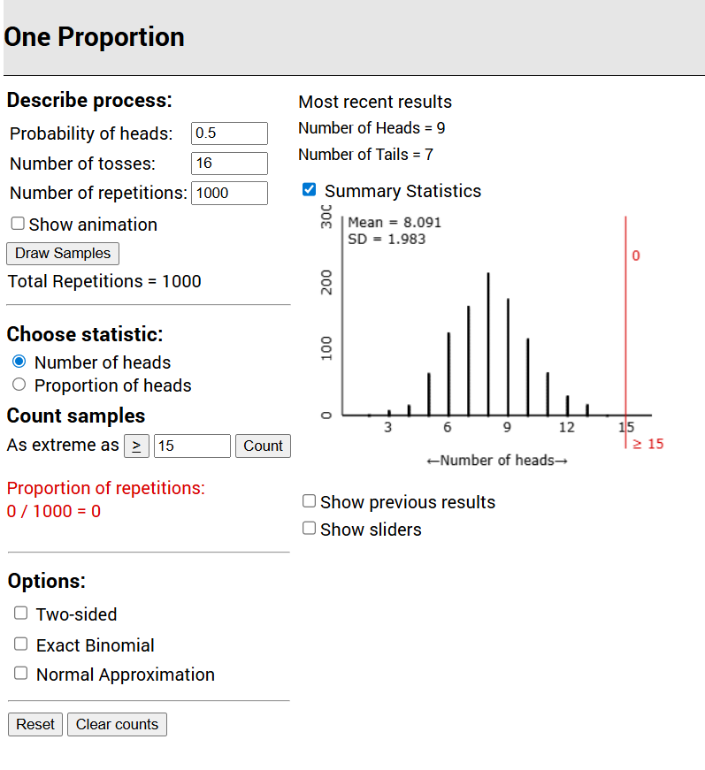
- Conduct this simulation analysis. Make sure the Proportion of heads button is selected in the applet and not Number of heads. Add your screenshot below.

- Indicate how to calculate the approximate p-value approximate p-value by filling the blanks (count the number of simulated statistics that equal __0.94__ or ___larger________).

- Report the approximate p-value.

0

- Use the p-value to evaluate the strength of evidence provided by the sample data against the null hypothesis, in favor of the alternative that students really do tend to assign the name Tim (as the researchers predicted) to the face on the left.

We have very strong evidence that the long-run proportion of Buzz’s attempts is more than 0.50.

Draw Inferences Beyond the Data – Theory - Based Approach

To investigate this claim, Dr. Bastian had Buzz attempt to push the correct button a total of 160 different times. In this sample of 160 attempts, Buzz pushed the correct button 150 out of 160 times (150\160 = 0.94). (Remember it was 16 attempts at the beginning but I increased sample size to be able talk about Central Limit Theorem)

- Define the population and explain in words what the parameter represents here.

Population: All possible attempts of Buzz (if he did this forever)
Parameter: Probability of correct push (π)

- Determine the sample proportion of Buzz pushing the correct button. Use the appropriate symbol to denote this.
$$\hat{p}= 150\backslash 160 = 0.9375$$

- Calculate and interpret the z-score corresponding to this sample proportion, assuming the null hypothesis is true.

$z=\frac{\hat{p}- π_{0}}{\sqrt{\frac{π_{0}(1- π_{0})}{n}}}= \frac{0.9375- 0.500}{\sqrt{\frac{0.5(1- 0.5)}{160}}}$ = 11.07

- For a hypothesis test about a population proportion, the test statistic is: $z=\frac{\hat{p}- π_{0}}{\sqrt{\frac{π_{0}(1- π_{0})}{n}}}$
- Use the CLT to determine the (approximate) probability that the sample proportion of correct attempts (𝑝̂) would be 0.9375 or larger in a random sample of 160 attempts, assuming that null hypothesis is true. (Also check whether the CLT conditions are satisfied in this study, assuming the null hypothesis to be true and draw a sketch of this sampling distribution.). Feel free to use Normal Probability Calculator Applet.

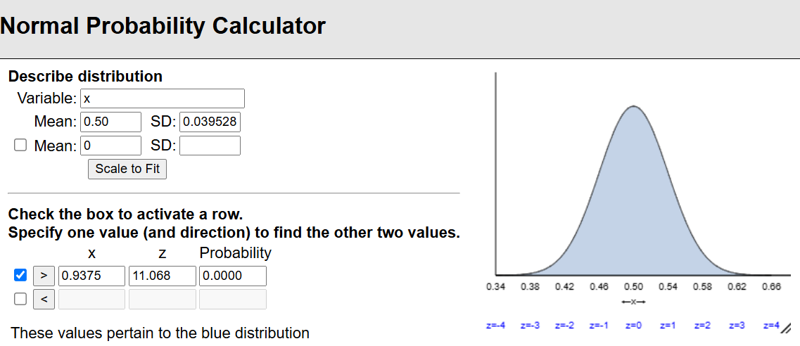

- By what term is this probability known?

p-value

- Now, Use the Theory-based Inference Applet to conduct hypothesis testing. Add your screenshot below. Find standard error, standardized statistics and p-value.

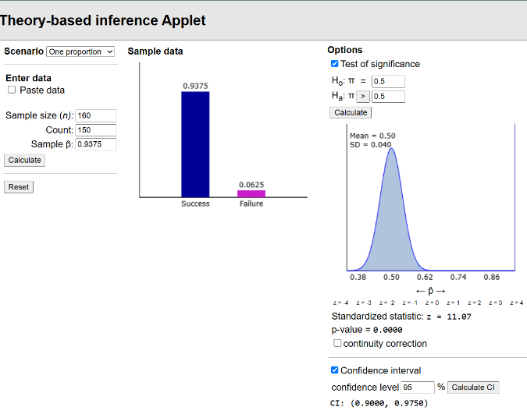

- Is this probability (p-value) small enough to provide strong evidence against the claim that Buzz was randomly guessing, in favor of the alternative hypothesis that Doris and Buzz have a genuine tendency to communicate abstract ideas in the long run? Also explain the reasoning process behind your answer.

Yes, we would reject the null hypothesis because it was super small

